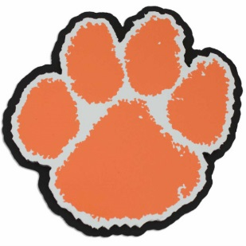
PANTHER
WRESTLING
NP

North Pitt Quad

Round | North Pitt Mat | Dark Blue Mat | Red Mat
1 | North Pitt vs. Manteo | Tarboro vs. North Lenoir | Hertford vs. South Lenoir
2 | North Pitt vs. Hertford | Tarboro vs. South Lenoir | Manteo vs. North Lenoir
3 | North Pitt vs. North Lenoir | Tarboro vs. Hertford | Manteo vs. South Lenoir
4 | North Pitt vs. South Lenoir | Tarboro vs. Manteo | Hertford vs. North Lenoir
5 | North Pitt vs. Tarboro | Manteo vs. Hertford | North Lenoir vs. South Lenoir

