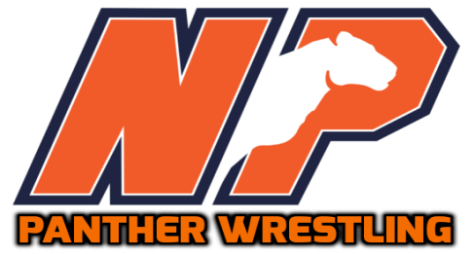
North Pitt Wrestling Schedule
Times can be found on the website.

Date | Event | Location
11/10 | Scrimmage | JH Rose
11/18 | Greene Central | North Pitt
11/19 | Pirate Duals | Swansboro
11/22 | Quad (Nash Central, Pamlico, East Duplin) | North Pitt
12/1 | Tri (Rosewood, Ravencroft) | Rosewood
12/3 | 25th Annual Pierce/Davis Memorial | North Pitt
12/7 | Pitt vs Wilson County (Hunt, Fike, Beddingfield) | Fike
12/10 | Eagle Invitational | Rosewood
12/13 | Conference (North Johnston, Washington) | Beddingfield
12/17 | North Pitt Invitational | North Pitt
12/20 | Tri (Eastern Wayne, Corinth Holders) | Eastern Wayne
12/22 - 12/23 | Tiger Classic Tournament | Chapel Hill
1/5 | Conference (Beddingfield, SWE, Farmville) | North Pitt
1/6 - 1/7 | First Flight Tournament | First Flight
1/11 | Quad (Richlands, Manteo, Hunt) | North Pitt
1/14 | Henry “Coach O” Overton Duels | Holmes
1/20 | Conference (North Johnson, Washington) | Farmville Central
1/21 | Pitt County Championships | Ayden-Grifton
1/25 | Conference (Beddingfield, SWE, Farmville) | Washington
1/28 | EPC Individual Championships | Farmville Central
1/31 | Team Playoffs - 1st/2nd Round | TBD
2/10-2/11 | Individual Regionals | Farmville Central
2/16-2/18 | Individual States | Greensboro Coliseum

Website:  http://npwrestling.weebly.com/ | Like Us On:
School Address:  5659 NC-11 South  Bethel, NC 27812  (252) 825-0054 | Head Coach: Chris Young  Athletic Director: Brent Wooten/Brady Quinn

